Chapter 4: System Implementation and Results

This chapter discusses the implementation details of the "Smart Career Path" system, starting from the development environment used, through explaining how the main system modules were built, and concluding with presenting the results achieved from the implementation process. It also highlights the main contributions of this project and suggests areas for future work.

4.1 Development Environment
The "Smart Career Path" system was developed using a set of open-source technologies that provide a powerful and flexible development environment. The development environment consists of the following components:

- Operating System: Windows.
- Web Server: Apache HTTP Server.
- Server-side Programming Language: PHP 8.x.
- Database Management System: MySQL 8.x.
- Frontend Technologies: HTML5, CSS3, JavaScript.
- Development Tools: A text editor such as VS Code, and a modern web browser for testing.

These technologies were chosen for their ease of use, large community support, and their ability to build robust and efficient web applications.

4.2 Implementation of Key Modules
The system implementation was divided into key modules, each responsible for a specific aspect of the system's functionality. This approach ensures ease of maintenance and future development.

4.2.1 User Management and Authentication
This module is the cornerstone of the system, providing secure mechanisms for user registration and login. It was implemented using PHP and MySQL.

- Registration: User information (username, email, password, full name) is collected and stored in the users table after hashing the password using the password_hash() function to ensure security.
- Login: User credentials (username and password) are verified against the data stored in the database. Upon successful login, a user session is created, and the user is redirected to their dashboard.
- Session Management: PHP sessions are used to track the user's state and maintain their login across different system pages.

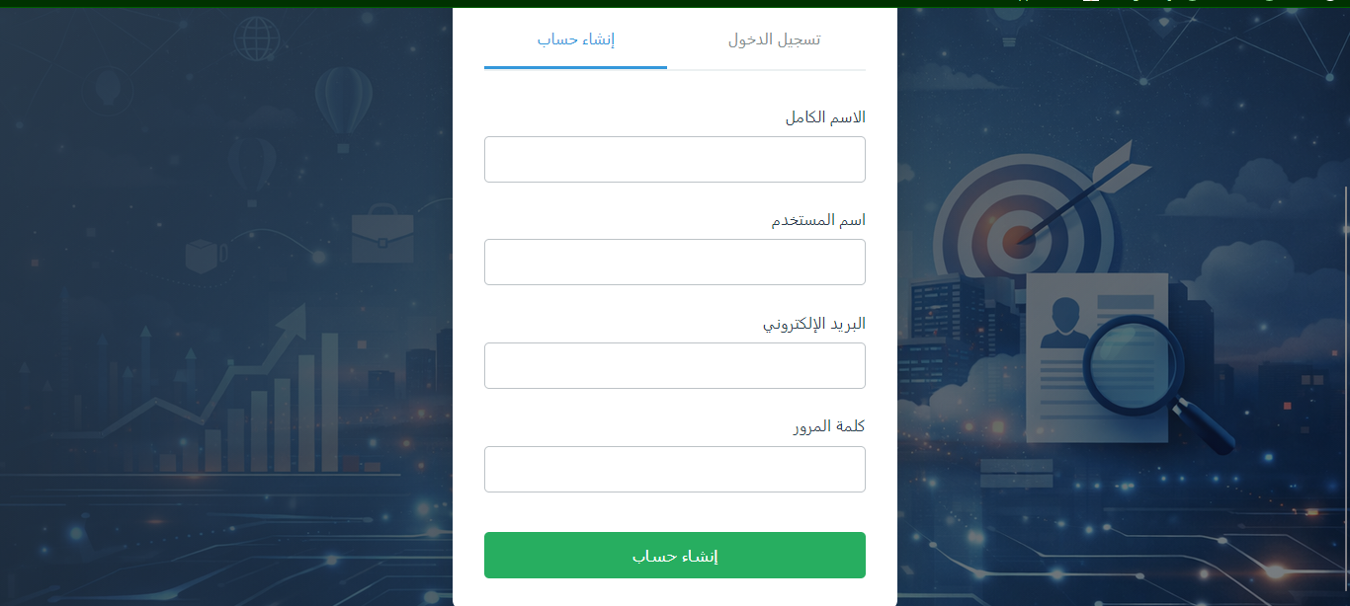
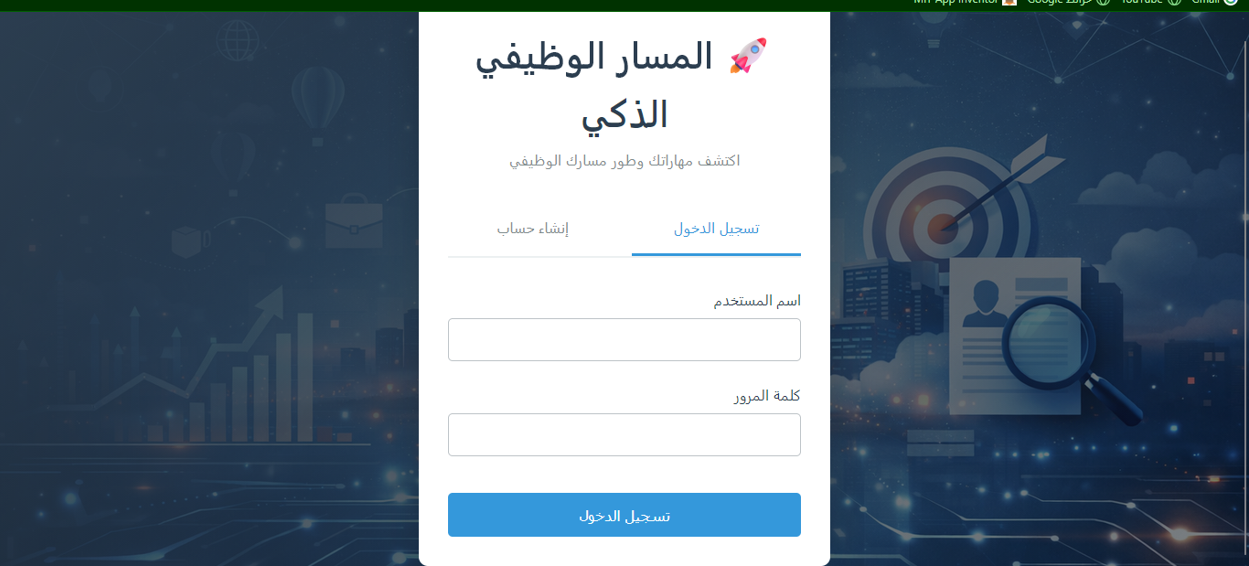

4.2.2 Skill Management
This module allows users to add and modify their skills, as well as manage the list of available skills in the system (for administrators).

- skills table: Stores a list of predefined skills in the system, along with their category and difficulty level.
- user_skills table: Links users with the skills they possess, specifying the user's proficiency level and years of experience.
- User Interface: A simple interface was provided for users to add their skills and select their proficiency level, facilitating the process of building their profile.

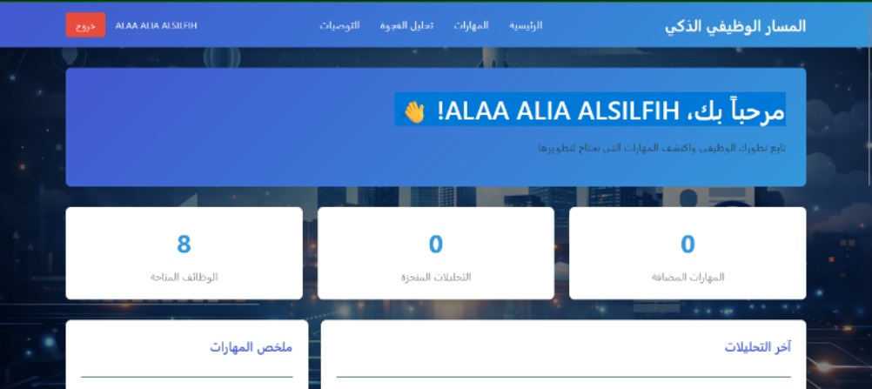
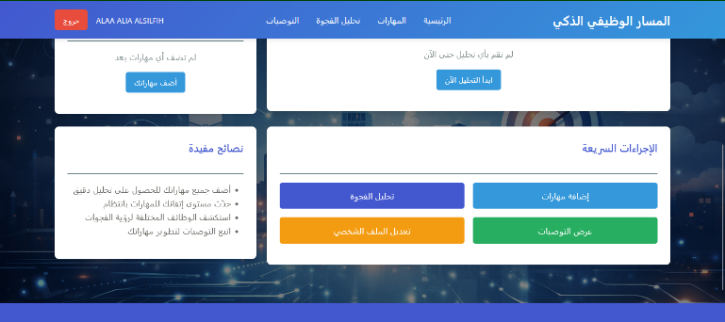

4.2.3 Skill Gap Analysis
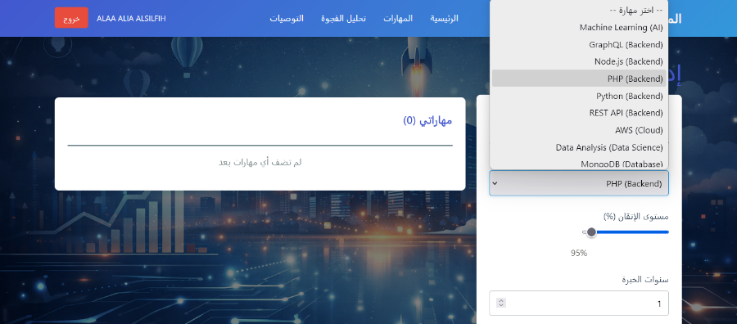
This is the core functionality of the system, comparing user skills with the requirements of a specific job.
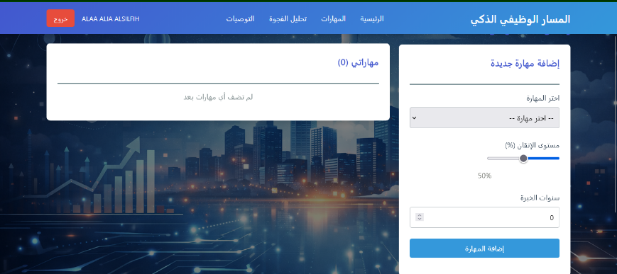
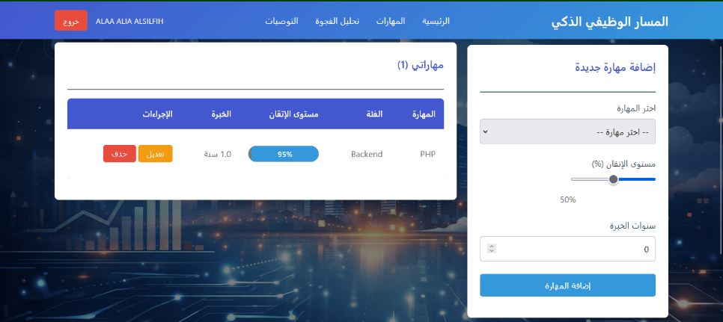
- Requirement Retrieval: When a user selects a job, the system retrieves the required skills for that job from the job_requirements table, considering the importance_level of each skill.

- Comparison and Calculation: User skills are compared with job requirements. A weighted match percentage is calculated based on an algorithm that considers the user's proficiency level and the importance of the skill for the job. Analysis results are stored in the skill_gap_analysis table.
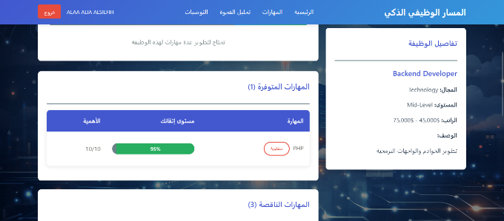

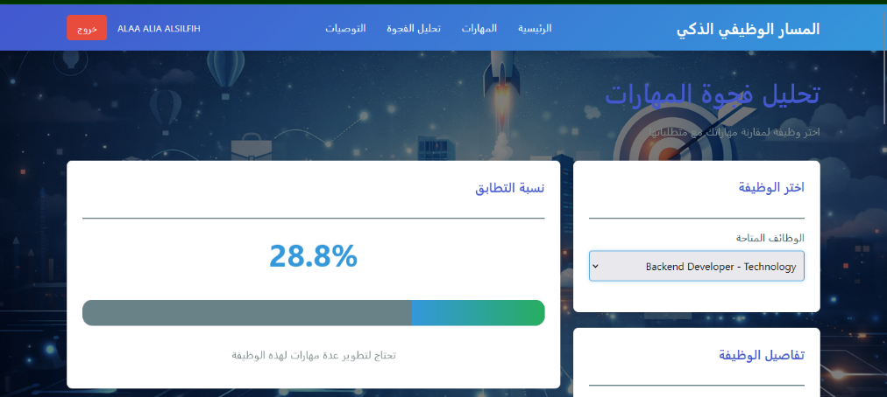
- Identification of Missing Skills: Skills required by the job but not possessed by the user are clearly identified, forming the basis for recommendations.

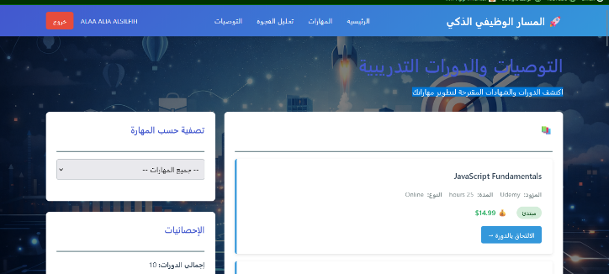
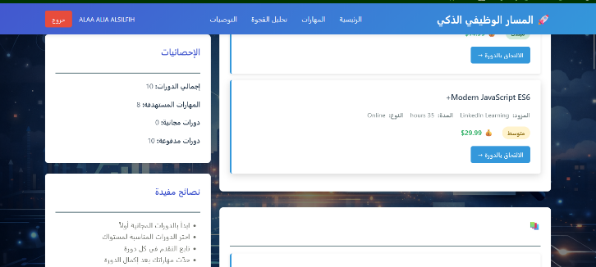
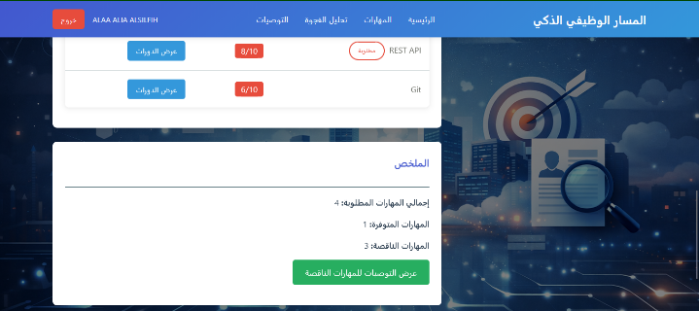
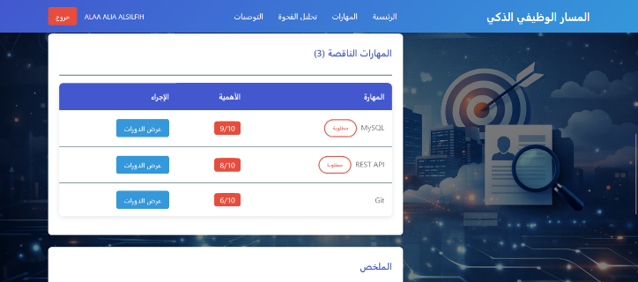

4.2.4 Recommendation System
Based on missing skills, the system provides personalized recommendations for training courses and educational resources.

- recommendations table: Contains a list of training courses, their provider, type, duration, difficulty level, along with the course link and rating.

- Skill Linking: Each recommendation is linked to a specific skill (skill_id), allowing the system to suggest relevant courses for skills the user needs to develop.

- Display Interface: Recommendations are clearly displayed to the user, with details of each course and direct links for enrollment.

4.2.5 Arabic Language Support
The system was designed to fully support the Arabic language, making it user-friendly for Arabic speakers. This includes:

- User Interface: All texts, buttons, and titles in the user interface are in Arabic.
- Text Direction: The text direction (Right-to-Left - RTL) was set to accommodate the Arabic language.
- Data: Sample data for jobs and skills was entered in Arabic into the database, demonstrating the system's ability to handle Arabic content.

4.3 Results
The implementation of the "Smart Career Path" system demonstrated success in achieving the project's defined objectives. A functional web application was developed that provides users with the necessary tools to analyze their skills and receive personalized recommendations.

- Intuitive User Interface: The user interface was designed to be user-friendly and intuitive, allowing users to easily navigate through system sections and input their data without difficulty.
- Accurate Skill Gap Analysis: The skill gap analysis algorithm proved capable of accurately identifying matched and missing skills, and providing a clear match percentage between user skills and job requirements.
- Relevant Educational Recommendations: The system was able to provide recommendations for relevant and useful training courses based on missing skills, offering users a clear roadmap for professional development.
- Multilingual Support: The system demonstrated full support for the Arabic language, enhancing its usability in the region.

The following figure illustrates an example of the main user interface after login (Dashboard):

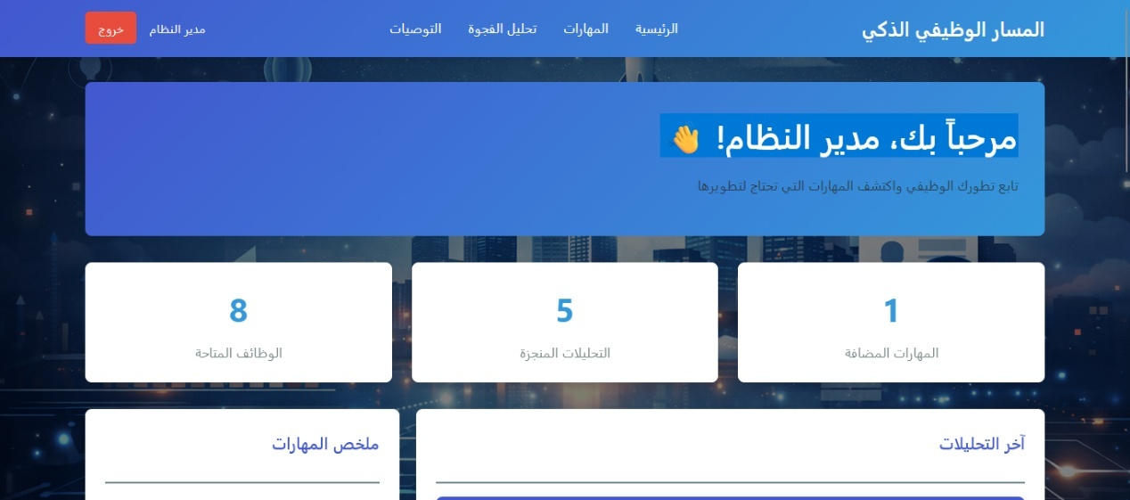

4.4 Contributions of the Study
This project offers valuable contributions to the field of career guidance and human capital development, notably:

- Integrated Skill Gap Analysis System: Provides a comprehensive solution that links personal skill assessment with labor market requirements, making it easier for individuals to define their career path.
- Personalized Educational Recommendations: Offers targeted educational recommendations based on a precise analysis of user needs, increasing the effectiveness of professional development efforts.
- Arabic Language Support: Enhances access to advanced career guidance tools for Arabic speakers, supporting localization initiatives and the development of local competencies.
- Scalable Model: The system was designed with an architecture that allows for future expansion and the addition of more features, such as automated CV analysis and integration of additional labor market data sources.

4.5 Future Work
Based on the results and challenges faced by the project, several future improvements and expansions can be suggested:

- Automated CV Analysis: Develop a Natural Language Processing (NLP) module to automatically extract skills from CVs in PDF or Word format, reducing manual effort for the user.
- Integration of Live Labor Market Data: Connect with Application Programming Interfaces (APIs) of popular job sites (e.g., LinkedIn Jobs, Indeed) to obtain updated data on vacant job requirements.
- Deeper Recommendation Personalization: Utilize Machine Learning techniques to improve the accuracy of recommendations, considering user preferences, educational history, and desired career path.
- Institutional Dashboard: Develop a dedicated dashboard for universities or companies to monitor common skill gaps among their students or employees, and provide targeted training programs.
- Support for Additional Languages: Expand system support to include languages other than Arabic and English, to increase its reach.
- Integration with Learning Platforms: Direct integration with e-learning platforms (e.g., Coursera, Udemy) to facilitate the enrollment process in recommended courses.

